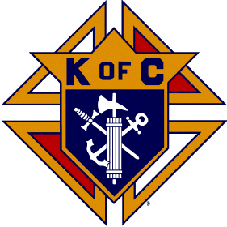
Knights of Columbus 14077
Faith In Action

Scholarship Information

The following requirements will make a member eligible for sponsorship of an applicant.

1. A council member in good standing. Good standing is defined as having current dues paid.

2. A point system is used to measure a member’s participation in the council and its activities. Participation is defined as having attended business meetings throughout this fraternal year and/or having been actively involved in council activities throughout the fraternal year.

3. A member must accumulate a minimum of 7 participation points to have his applicant eligible for consideration. The following point system will be utilized.

- 1 point for attending a monthly KC meeting and/or a sanctioned event.
- 2 points for working an event.

The following requirements will make an applicant eligible for consideration of funds.

1. The applicant must email their application with their attending institution to daudino@tcco.com no later than 8/1/25.

2. The applicant must be either a current Knight in good standing or the son/daughter/grandson/granddaughter of an active member of the Council.

3. The applicant will submit a short essay on the following topics with one paragraph on each of the following:
A. What your faith means to you and how do you evangelize your faith.
B. Career goal statement.
C. Participation in extracurricular activities (high school/college and the community).
D. Volunteer Work History, with special emphasis on service to the Church
4. Essays will be evaluated on the following: content, spelling, grammar, punctuation, and the applicant’s ability to thoroughly address the topics. Each area will be weighted 1 point with a maximum of 5 points per essay.

5. Failure to meet the application requirements will result in a disqualification.

